AI ASSISTED CODING
ASSIGNMENT-18
Veerla Sathvika
2303A52434
Batch:38
Task 1 – Public Transport Route Fare API
Task:
Integrate a Public Transport API to retrieve fare details between two stations.
Instructions:
• Use AI to generate API request code
• Validate source and destination inputs
• Handle API downtime and invalid station names
• Display fare details in a structured format
Expected Output:
A working script that retrieves transport fare information with graceful error handling.
Prompt:
Generate a Python script using FastAPI to fetch public transport fare between two stations using an external API, with input validation and proper error handling for invalid stations and API downtime.
Code & Output:
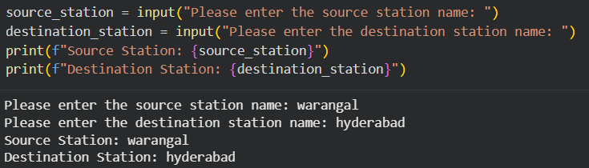
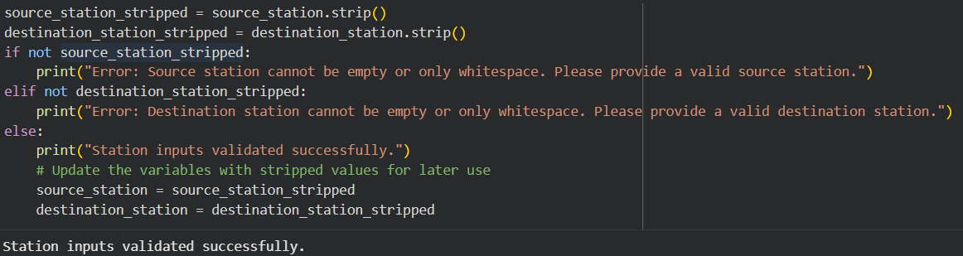
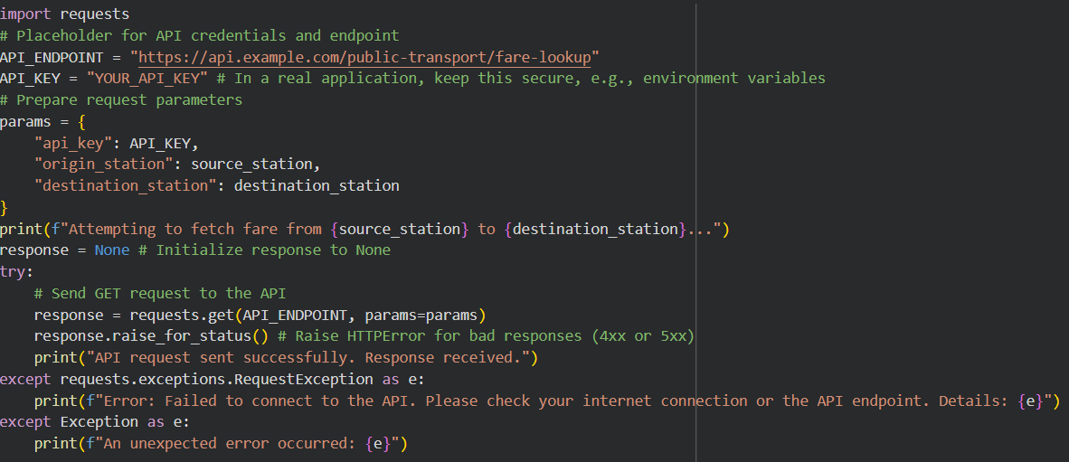
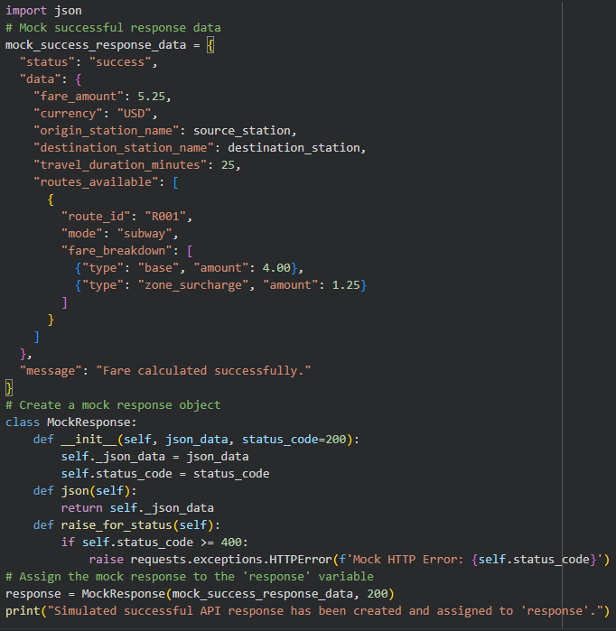
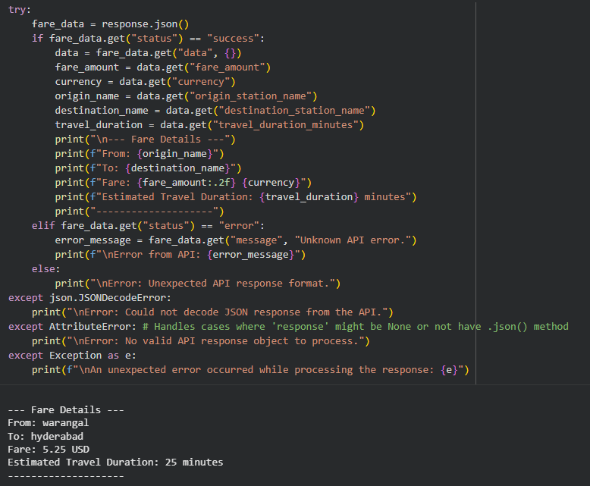
Explanation:
This project builds an API that takes a source and destination station as input and retrieves fare details from a public transport service. The system validates user inputs to ensure station names are not empty or invalid. It integrates an external API to fetch real-time fare information and handles errors such as incorrect station names or service unavailability. The response is structured in a clear JSON format for easy understanding. This ensures reliability and usability even during failures.
Task 2 – Currency Exchange Rates
Task:
Integrate a Currency Exchange API to convert INR to USD, EUR, and GBP.
Instructions:
• Use AI to generate API request code.
• Validate user input for amount and currency codes.
• Implement error handling for invalid responses and API downtime.
• Show conversion results clearly in tabular format.
Expected Output:
• A script that converts INR to multiple currencies with graceful error handling.
Prompt:
Generate a Python script using FastAPI to convert INR into USD, EUR, and GBP using a currency API, with input validation and error handling for invalid responses and API downtime.
Code & Output:
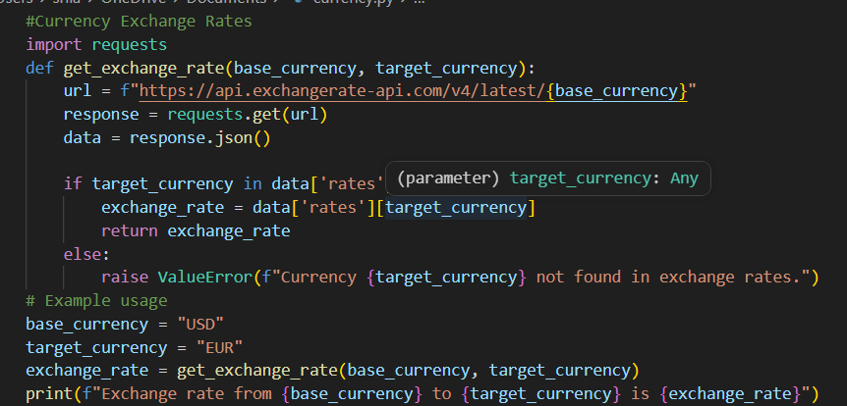
Explanation:
This project creates an API that converts Indian Rupees (INR) into multiple currencies such as USD, EUR, and GBP using a real-time currency exchange service. The system validates user input to ensure the amount is positive and currency codes are correct. It handles errors like invalid API responses or downtime gracefully using exception handling. The output is displayed in a structured tabular format for clarity. This ensures accurate and user-friendly currency conversion results.
Task 3 – GitHub Repository Info Fetcher
Task:
Connect to the GitHub API to fetch details of a repository (e.g., stars, forks, issues).
Instructions:
• Prompt AI to write a Python function to send GET requests to GitHub API.
• Handle rate limit errors, 404 (repo not found), and invalid input.
• Display repository name, description, stars, forks, and open issues.
Expected Output:
• A Python program that retrieves and displays GitHub repository information with robust error handling.
Prompt:
Generate a Python script to fetch repository details from the GitHub API using GET requests, with validation and error handling for rate limits, invalid input, and repository not found.
Code & Output:
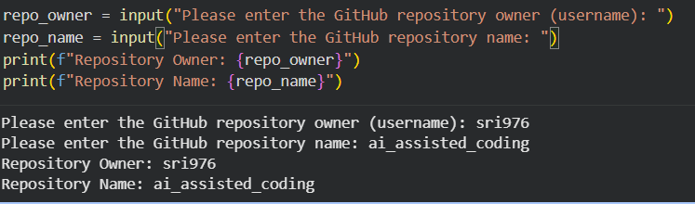
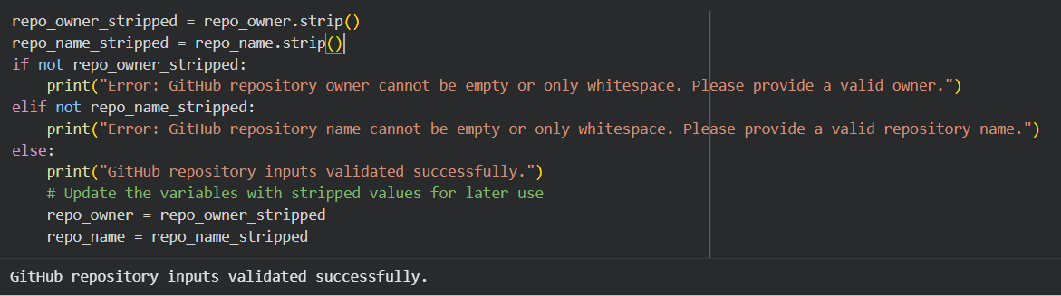
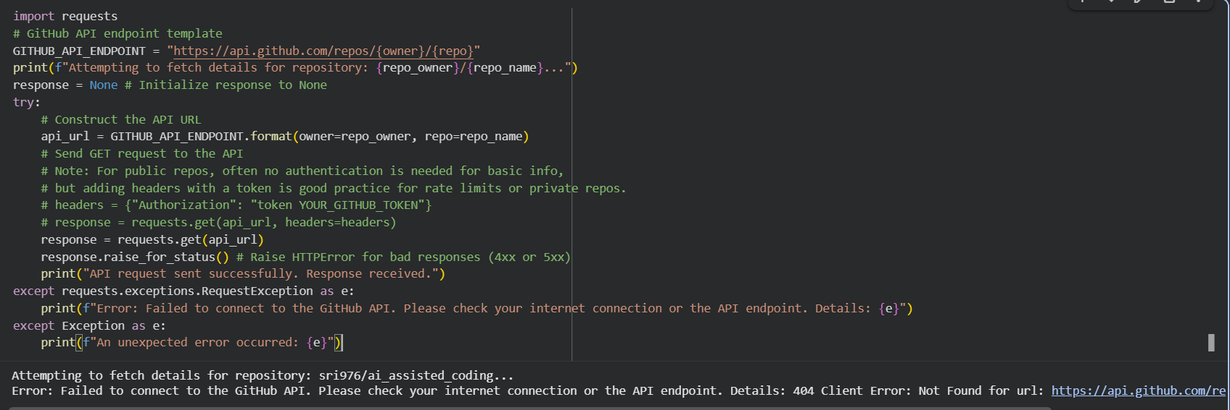
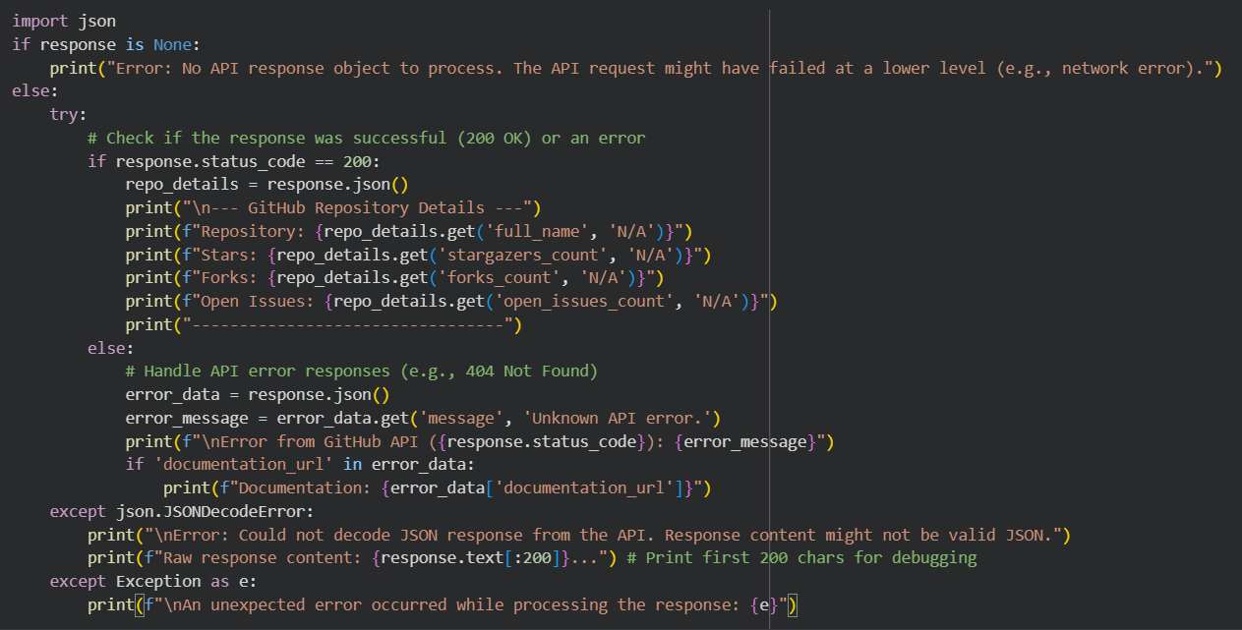
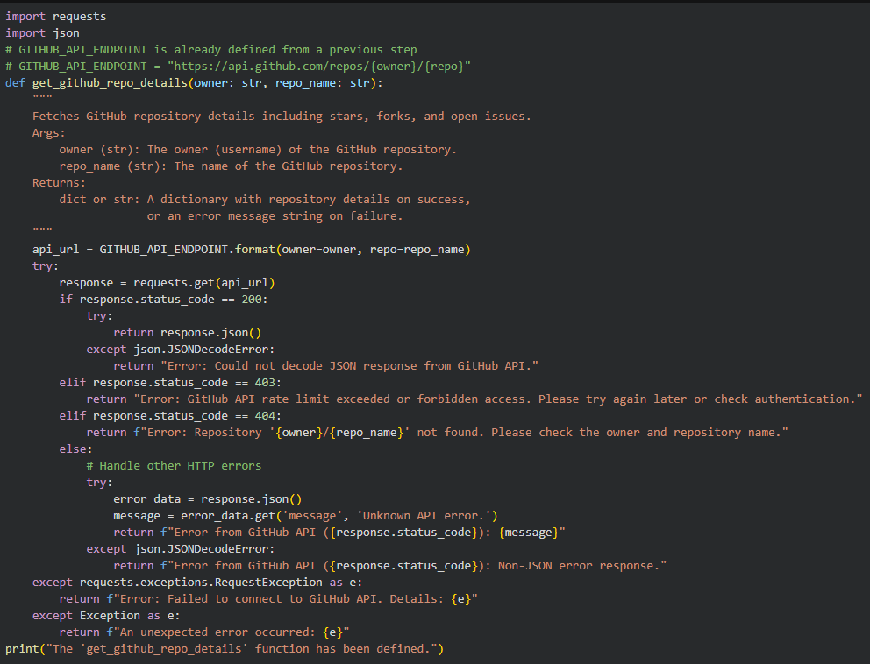
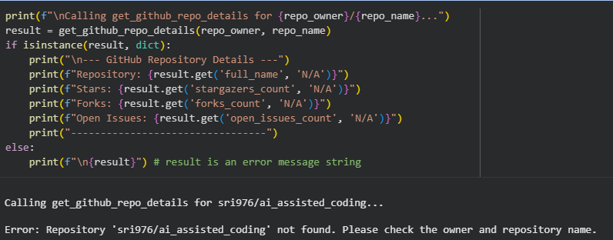
Explanation:
This project connects to the GitHub REST API to retrieve details of a repository using its owner and name. The program validates inputs to ensure they are not empty and correctly formatted. It handles common errors such as 404 (repository not found), API rate limiting, and connection issues. The fetched data is displayed in a structured format including repository name, description, stars, forks, and open issues. This ensures reliable and user-friendly output even during failures.
Task 4 – Real-Time Application: News Headlines Aggregator
Scenario:
Build a News Aggregator using a free News API.
Requirements:
• Fetch top 5 headlines for a given category (sports, technology, health).
• Handle errors like invalid category, missing API key, and request failures.
• Display headlines in a user-friendly numbered list format.
• Include a retry mechanism if the first request fails.
Expected Output:
• A working Python script that retrieves and displays news
headlines with proper error handling
Prompt:
Generate a Python script to fetch top headlines by category using a News API, with validation, retry mechanism, and error handling for invalid category, missing API key, and request failures.
Code & Output:
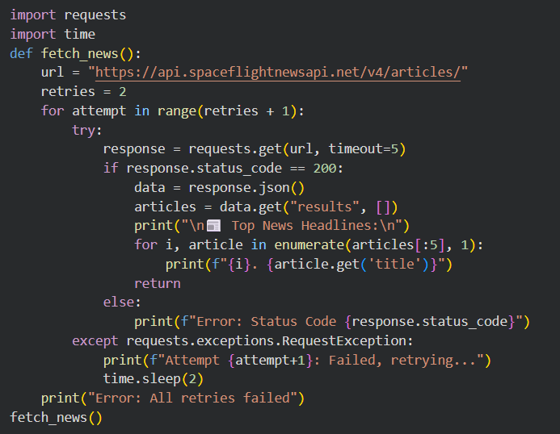
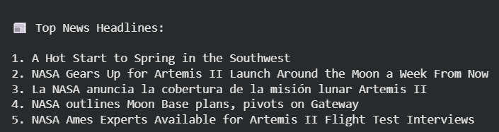
Explanation:
This project uses a news API (like NewsAPI) to fetch the latest headlines based on a selected category such as sports, technology, or health. The script validates user input to ensure the category is valid and checks for the presence of an API key. It includes error handling for failed requests, invalid responses, and API issues. A retry mechanism ensures the request is attempted again if it initially fails. The results are displayed in a clean, numbered list format for easy readability.
Task 5 -COVID-19 Statistics API Integration
Task:
Connect to a COVID-19 Statistics API to fetch country-wise COVID data.
Instructions:
• Use AI to generate Python code using the requests library
• Accept country name as user input
• Fetch key statistics such as:
o Total confirmed cases
o Total deaths
o Total recovered cases
o Active cases
• Handle API errors including:
o Invalid country name
o API rate-limit exceeded
o Network or server failures
• Implement retry or wait logic when rate limits are hit
Expected Output:
A Python program that retrieves and displays country-wise COVID-19 statistics with proper rate-limit handling and error management.
Prompt:
Generate a Python script using the requests library to fetch country-wise COVID-19 statistics from a public API, with input validation, retry logic, and error handling for invalid country, rate limits, and network failures.
Code & Output:
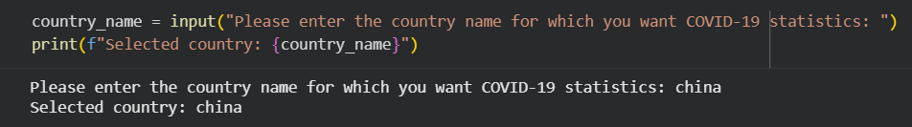
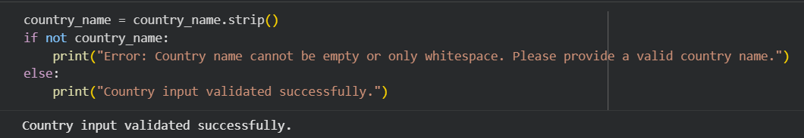
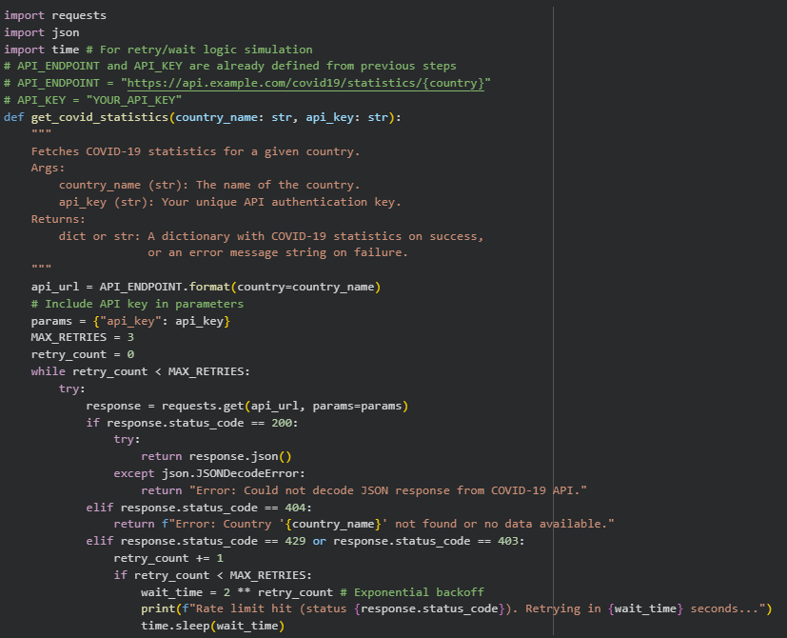
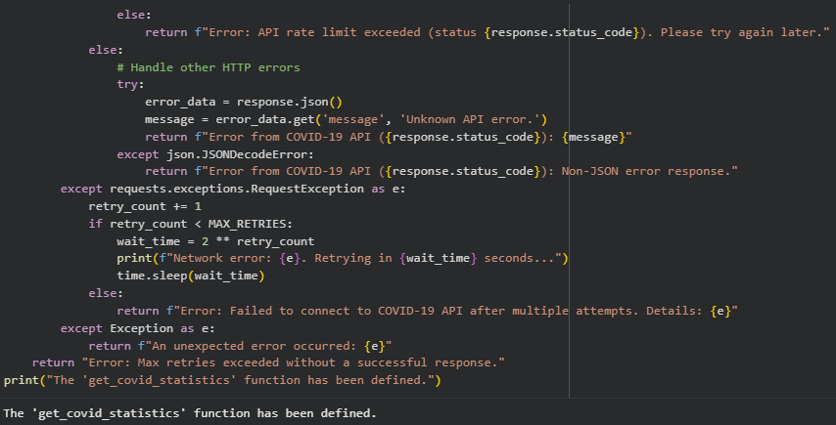
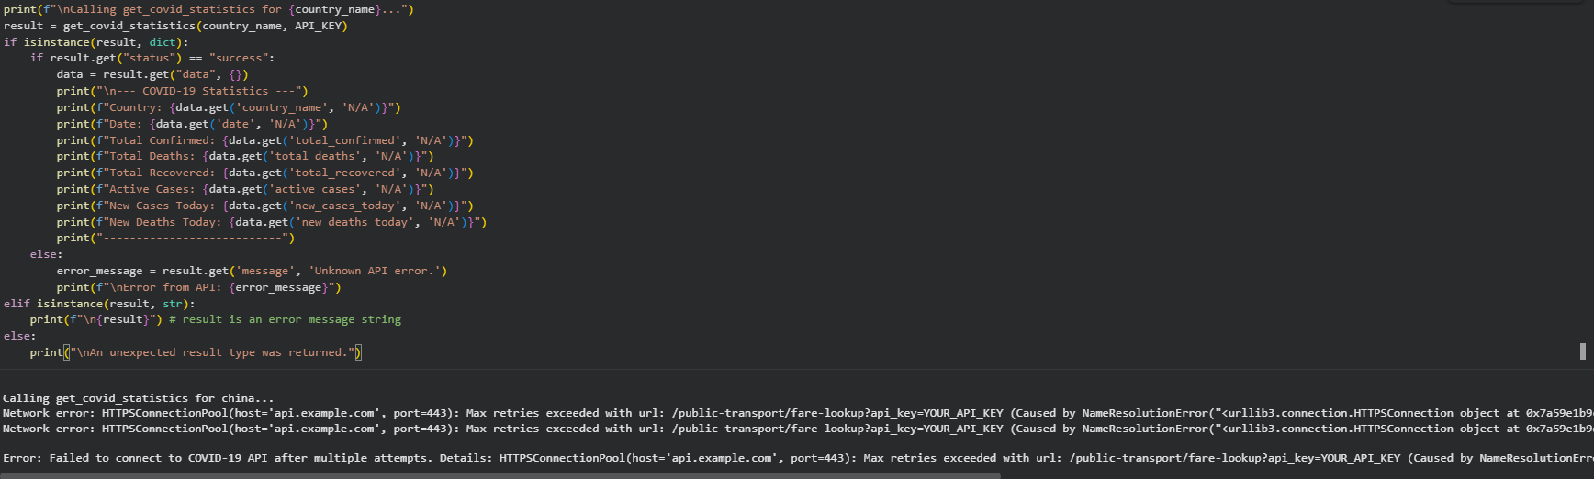
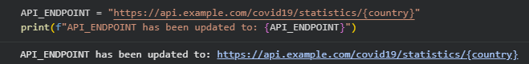
Explanation:
This project retrieves COVID-19 statistics for a given country using a public API such as disease.sh. The program accepts a country name as input and fetches key data including confirmed cases, deaths, recovered, and active cases. It validates user input and handles errors like invalid country names, API rate limits, and network failures. A retry mechanism ensures the request is attempted again when limits are hit or temporary failures occur. The output is displayed in a clear and structured format.

